|  |
| --- |
| College LaSalle |
| Project - Internet Programming User Manual |
|  |
| Presented to: Mr. Mihai Maftei |

|  |
| --- |
| Author: Samuel Fauteux  4/18/2021 |

Describe your application by using print-screen images and a short description (use simple words) to describe what happens (the functionality of…) with each page/button/link/field of your web site.

NB. IE does not work because of the secure tag in cookies

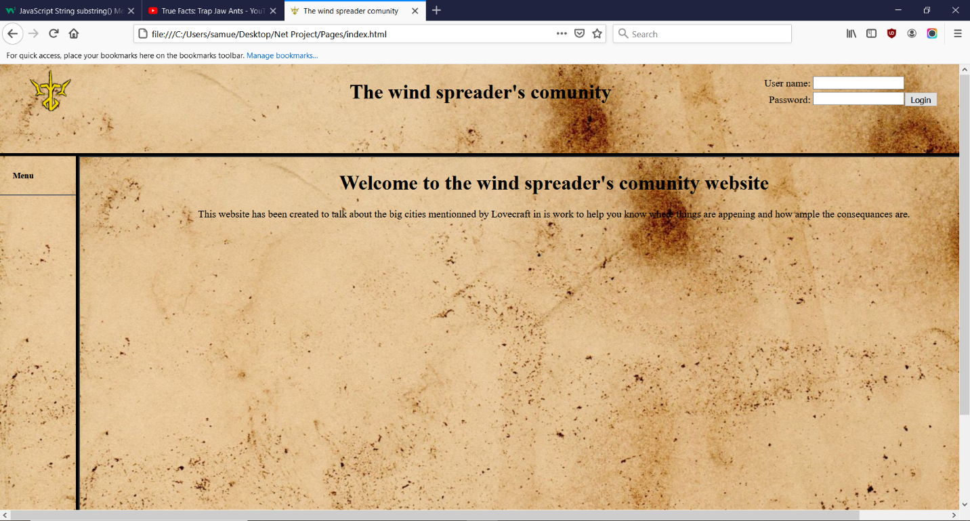

This is the first page you see, you can login or… that’s pretty much it. On a failed login attempt, you will be sent to the registration page, otherwise, you will be welcomed and the menu will be revealed:

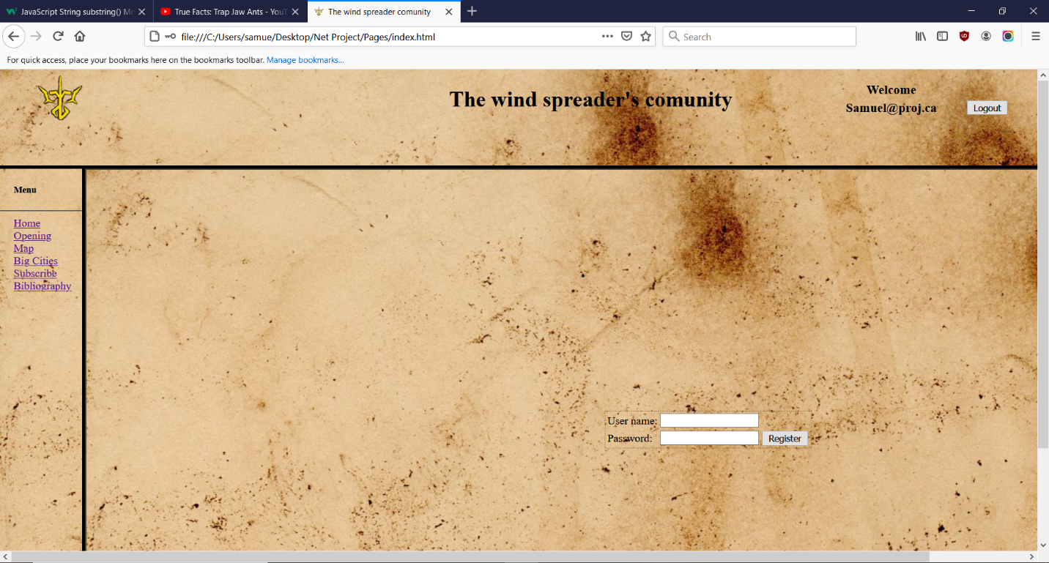

Here, you can see that I logged with the default username, the registration page and the menu.

For the menu, it only change the large part of the frame to the specified page.

Home: to the one in the first screenshot

Opening: The opening page

Map: A 1922 map showing a part of Massachusetts.

Big Cities: An informative page about the big cities on the map

Subscribe: The subscription page

Bibliography: The page where credit is given

The registration pages only have two fields and a button, if both are filled and the input accepted, once you clicked on the button, you will be able to register as that user. You will be warned if you can or not.

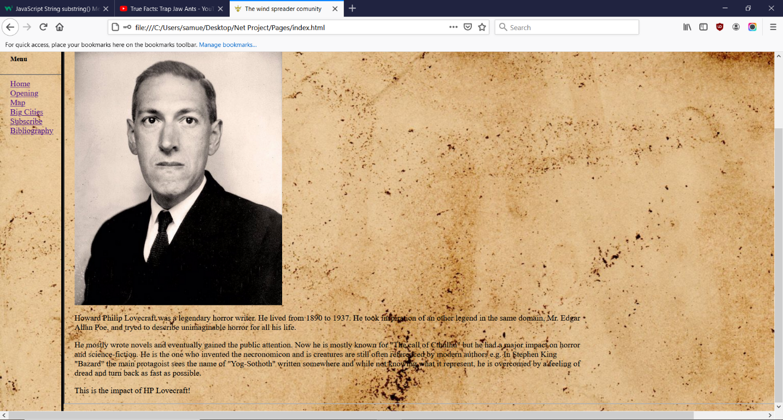

The opening page introduces a bit Lovecraft and his impact.

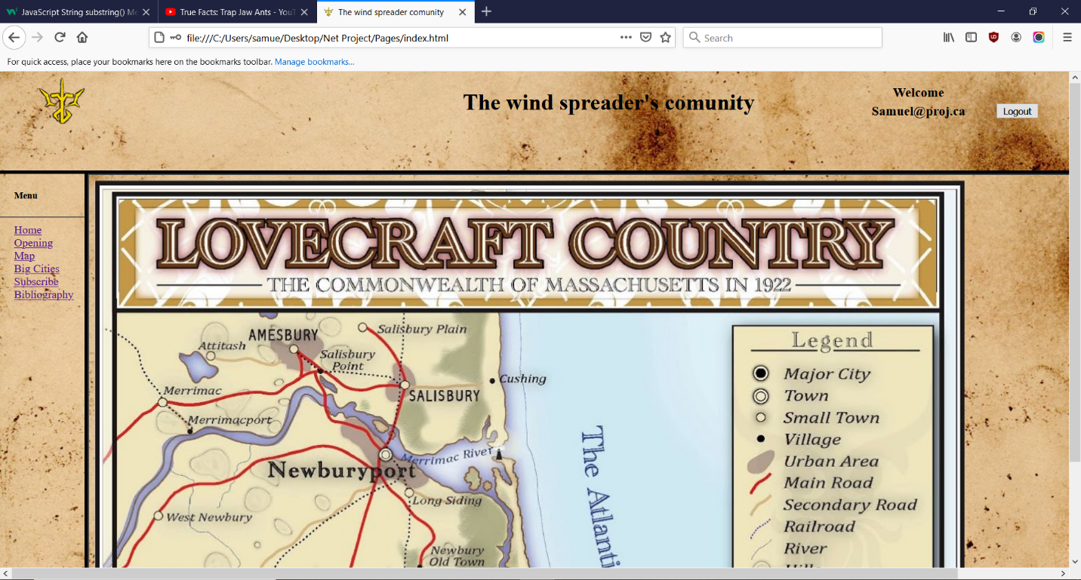

This is the map, you can click on major cities like Newburyport and be brought to info about it. (The info is actually in the Big Cities page)

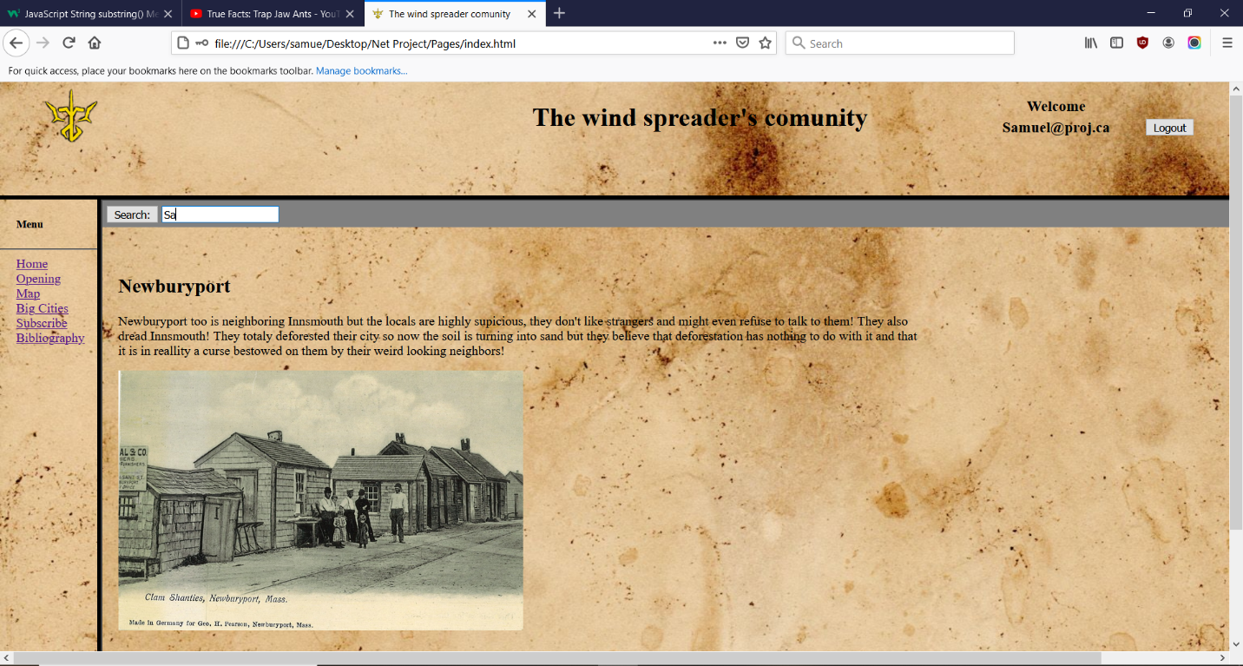

The Big Cities page contain all the info of the cities covered by the map. You can also search them in the search bar and there is a suggestion feature, I just wasn’t able to screenshot it. The search bar is sticky.

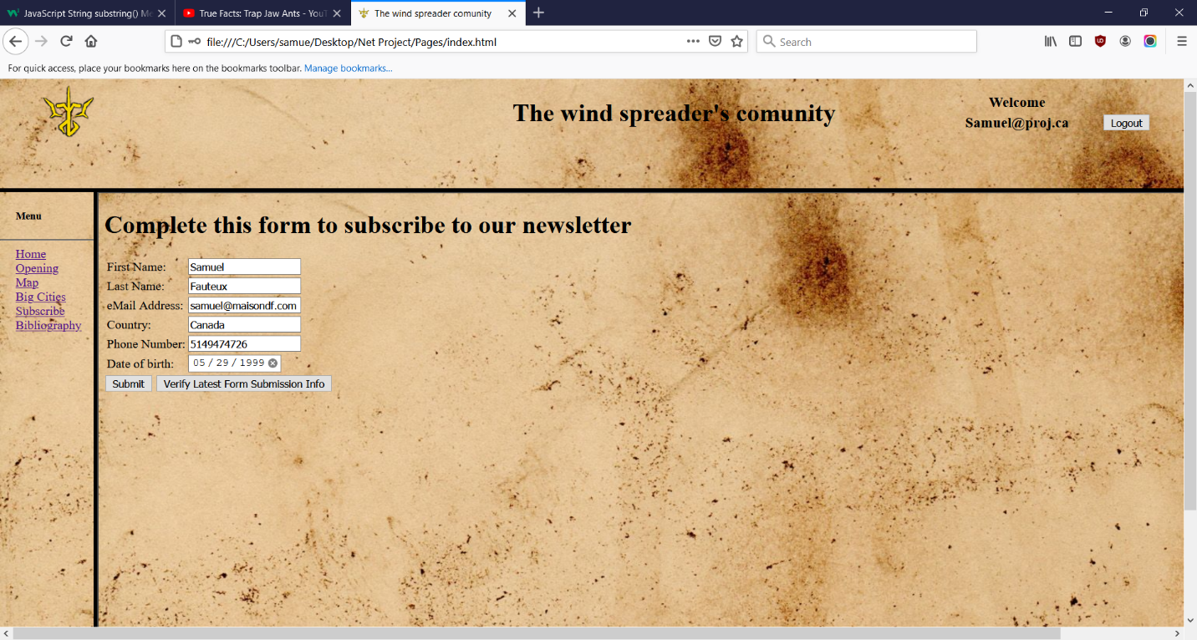

This is our subscription page when you click on submit, it will verify the info you are giving us and tells you if you are now subscribed or if your info are invalid. The super long button leads you to a page where you can verify the info you submitted:

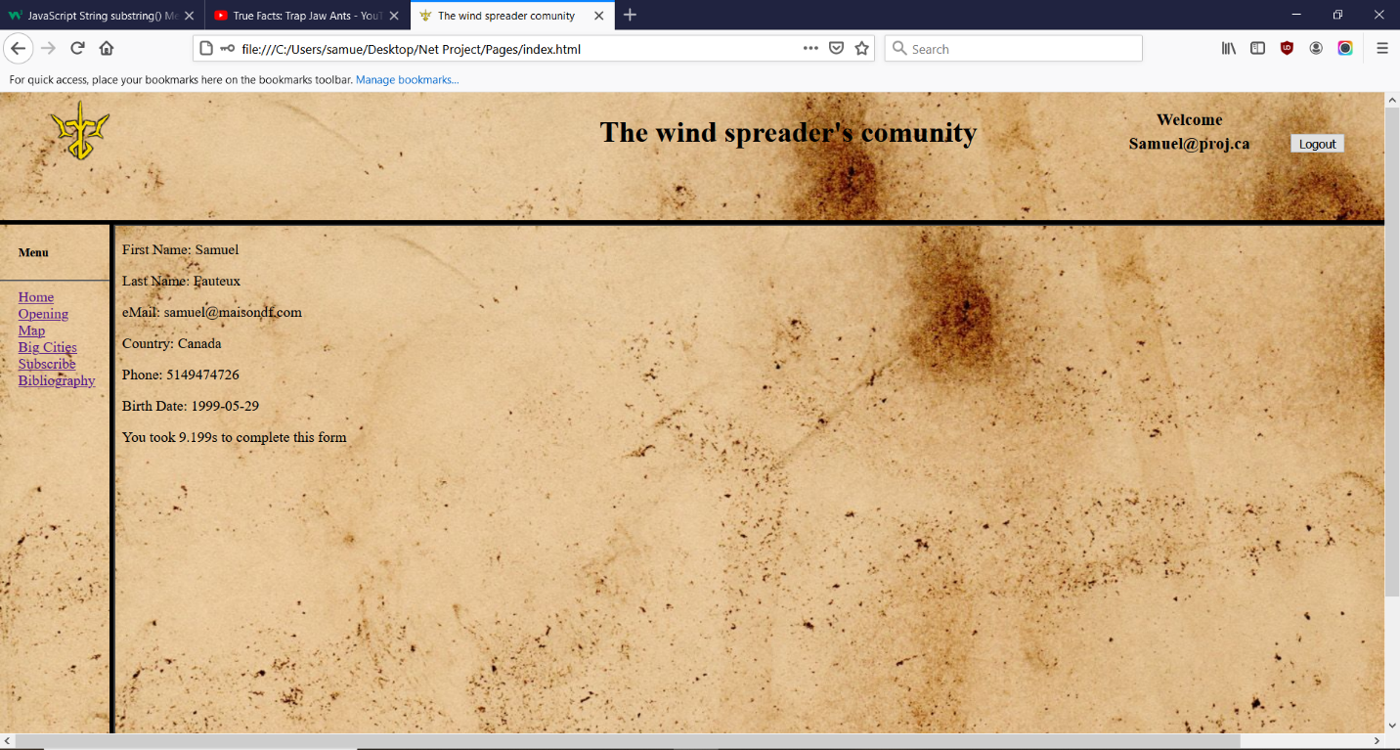

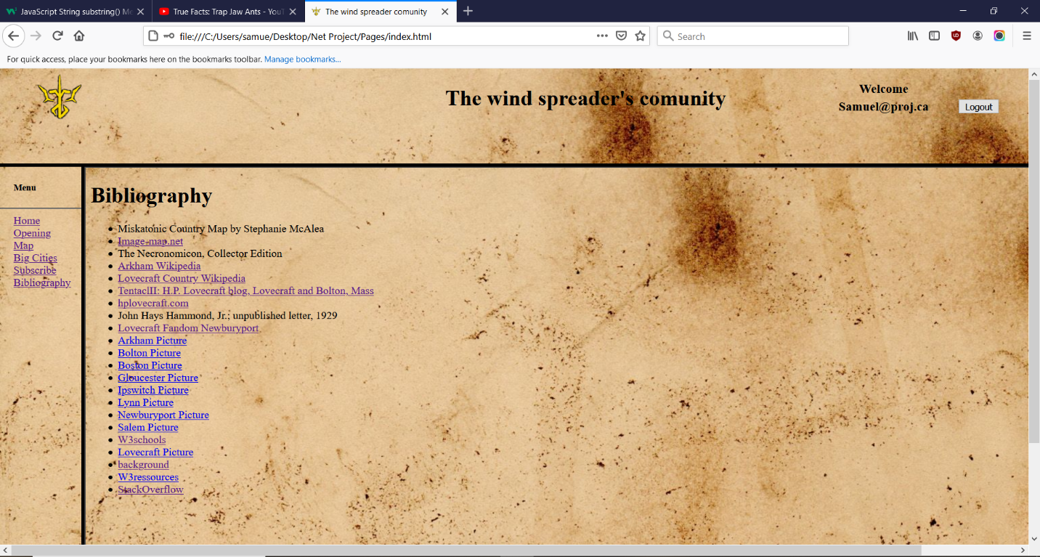

The lines that are not link to the source in the bibliography are titles of paper documents I own. (yes, the map is a scan)